Assignment 8

VC dimension of perceptrons

The Basics
Wednesday 10/29: I’m giving a little extra time for your groups to finish up the previous assignment. You can do so, or get started on this one. They are closely related.

Friday 10/31: studio class devoted to this assignment.

Monday 11/3: studio class devoted to this assignment.

Wednesday 11/5: studio class devoted to this assignment.

Friday 11/7: class presentation

Friday 11/14: final version due in class.

You will prove the claim mentioned in the last slide in the presentation in class on 11/6 (slides are available in the Content section of the mycourses page):

Theorem X. The VC dimension of the linear classifiers over  is 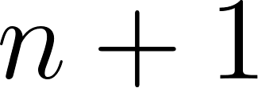.

Proofs of this exist online, however, they generally rely on linear algebra, which is a great tool, but it is rather technical. Instead, we will aim for geometric proofs. Geometric proofs are interesting because nearly any seemingly obvious claim or assumption can often be explained more rigorously. Your goal here will to come up with as complete and rigorous a proof as possible for the general case of  by studying in detail my geometric proof for 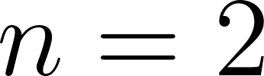. You will then provide the case for 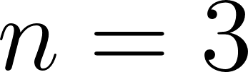, and finally arbitrary .

For these proofs we will rely on the following definition:
We say a line separates a pair of points,  if it intersects the line segment 

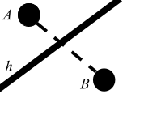

And the following lemma (without proof).
Lemma A. Any line that passes through the interior of a convex polygon separates the polygon into two pieces, where each piece contains at least one vertex.
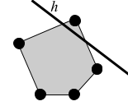

My proof of :

For a set of points that shatters 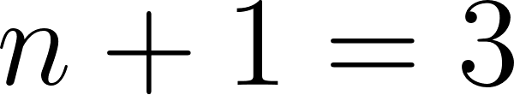, consider any three points 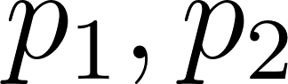 and 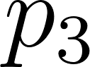 that form the vertices of an equilateral triangle.

If these points are given the same “color” (i.e., 0 or 1), then any line that passes below all three points works.

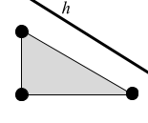

Otherwise, assume WLOG that  is the point that has a different color from the others. Let  be the line that is parallel to the line segment 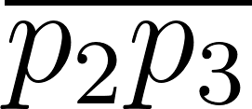 that bisects 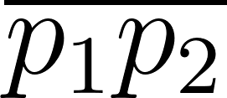. Then  divides  from the other points, as needed.

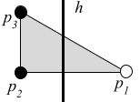

To show that the linear classifiers over 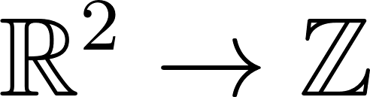 do not shatter n+1 = 4, let 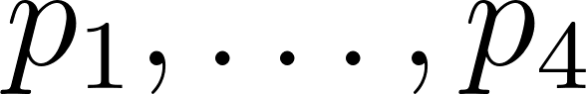 be any four points in 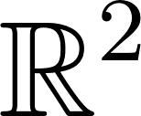. Assume that they are in general position (i.e., no three points are colinear), because that case is easy and we’ve seen it before.

Case 1. Three points (WLOG 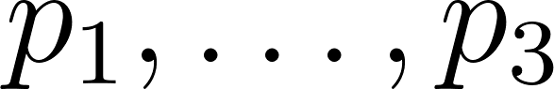) lie on the exterior of the convex hull and the fourth lies in the interior. So any classifier that separates the points must pass through the interior of the convex hull. By Lemma A, any classifier  that passes through the interior separates the hull into two pieces, both of which contain at least one point in . Moreover, one of those pieces must also contain 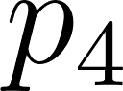 in its interior, so that piece has two different colors. Those  cannot shatter .

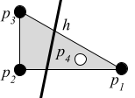

Case 2:  all lie on the convex hull. In that case, assume WLOG that  appear consecutively as one traverses the exterior of the hull. Assign  alternating colors (i.e., ). So any classifier that separates these points must pass through the interior of the hull. By Lemma A, any classifier  that passes through the interior separates the hull into two pieces, both of which contain at least one point in . Then the piece that contains more than one point must contain two different colors (since the colors alternate and only one cut is made. Thus  cannot shatter .
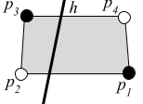

Why must one piece contain at least two colors? Note that if we consider only the border of the hull that if we remove the white nodes it separates the black nodes from each other. Therefore if a section contains both white nodes it must also contain a black node. The other piece contains a black node, but since the white nodes separate the black nodes the other black node must be with them or the hull would be separated into three pieces, which cannot happen. (If the white nodes are in separate sections then the classifier did not shatter them.)

Now, let’s work through the case with three dimensional points.

Q1. What does a linear classifier look like in three dimensions? Recall from the slides that for some .

Q4. What is the equivalent of the convex hull for  for three dimensional points?

Q3. What is the equivalent of Lemma A for  for three dimensional points?

Q4. Show that the linear classifiers (and thus perceptrons) over  shatter 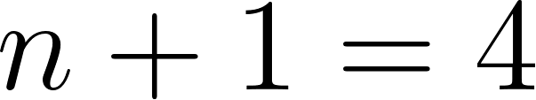, at the same level of detail as our proof of  above. Include a similar drawing and label and denote all similar features.

Q5. Show that the linear classifiers (and thus perceptrons) over  do not shatter 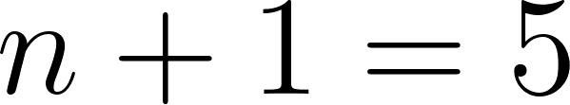, at the same level of detail as our proof of  above. Include a similar drawing and label and denote all similar features.

Q6-Q10 [OPTIONAL]. Repeat Q1-Q5, except now assume only some arbitrary number of dimensions d for the points. Your answers should have the same detail as Q1-Q5, except that you do not have to draw pictures (though you can if it makes your explanation easier).

